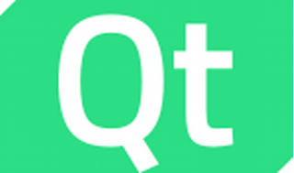

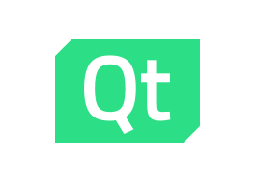

Explore

Certainly! **Qt** is a comprehensive **cross-platform development framework** that provides a rich set of modularized C++ library classes and APIs. [It simplifies application development, resulting in highly readable, maintainable, and reusable code with excellent runtime performance and a small footprint1](https://www.qt.io/product/framework).

Here are **five free resources** where you can learn more about Qt:

1. [**Qt Academy**](https://www.qt.io/academy): An eLearning platform offering top-quality courses for Qt users, partners, and learners. [Explore curated learning paths or individual courses to enhance your Qt skills](https://www.qt.io/product/framework)[2](https://www.qt.io/academy).
2. [**Udemy**](https://www.udemy.com/topic/qt-framework/): Udemy provides a range of QT courses, from basic to advanced. [Learn how to use Qt Creator and build applications in the Qt framework](https://www.qt.io/product/framework)[3](https://www.udemy.com/topic/qt-framework/).
3. [**PyQt Tutorial**](https://www.pythontutorial.net/pyqt/): Dive into PyQt, a Python binding for Qt. [Explore topics like QML, GUI design, and more](https://www.qt.io/product/framework)[4](https://www.pythontutorial.net/pyqt/).
4. [**Qt QML Documentation**](https://doc.qt.io/qt-6/qtqml-index.html): Learn about Qt’s QML module, which enables you to develop applications and libraries using the QML language. [Understand how to integrate QML with JavaScript and C++](https://www.qt.io/product/framework)[5](https://doc.qt.io/qt-6/qtqml-index.html).
5. [**Qt Resources**](https://www.qt.io/resources/qt): Qt’s official resource center offers webinars, use cases, whitepapers, and other learning materials to expand your knowledge[6](https://www.qt.io/resources/qt).

Happy learning! 🚀📚